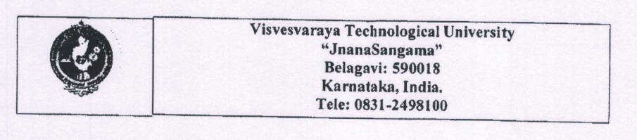

**VTU Sposnosred Student Project Proposal**

| 1. | **Academic Year: 2021-22** |
| --- | --- |
| 2. | **Semester: 8** |
| 3. | **Name of the College: BMS Institute of Technology** |
| 4. | **Branch: Computer Science and Engineering** |
| 5. | **Project Title: Pressure Ulcer Prediction and Prevention** |
| 6. | **Project Discipline: IOT - Medical Application** |
| 7. | **Principal:**  **Name: Dr. Mohan Babu G N**  **Email id: principal@bmsit.in**  **Contact No.:** |
| 8. | **HOD:**  **Name: Dr. Thippeswamy G**  **Email id: hod_cse@bmsit.in**  **Contact No.: 94488 64856** |
| 9. | **Project Guide:**  **Name: Prof. Mrs. Durga Bhavani A**  **Email id: durga842004@bmsit.in**  **Contact No.: 89514 40755** |
| 10. | **Project Co-Guide(If Any):**  **Name: -**  **Email id: -**  **Contact No.: -** |
| 11. | **Project Committee Coordinator:**  **Name:**  **Email id:**  **Contact No.:** |
| 12. | **Name of Team Members:**     1. **Group Leader and Member**   **Name: A Nitya Dyuthi  USN No.: 1BY18CS001**  **Email id:** [**nityaa55@gmail.com**](mailto:nityaa55@gmail.com)  **Mobile No:9353704080**     1. **Group Member**   **Name: Khushwinder Singh**  **USN No.: 1BY18CS0074**  **Email id: khushwinder99@gmail.com**  **Mobile No.: 9354247571**     1. **Group Member**   **Name: Likith S**  **USN No.: 1BY18CS081**  **Email id: likithsrinath2000@gmail.com**  **Mobile No.: 8310887310**     1. **Group Member**   **Name: Prakhyat**  **USN No.: 1BY18CS108**  **Email id: prakhyat13@gmail.com**  **Mobile No.: 9632440294** |
| 13. | **Scope / Objectives of the project:**  Due to the advent of COVID-19, the number of bedridden patients has soared. The lack of mobility and other important factors cause bedridden subjects to develop decubitus ulcers.  Decubitus Ulcers (DU) are dangerous and can have severe consequences, leading to long-term hospitalization. At more severe stages, bedsores become very painful, and the patient is at risk of surgery and even death. The goal of this project is to predict and prevent the formation of bedsores without human intervention. Prevention techniques in hospitals and retirement homes today are still traditional, where the healthcare personnel/caretaker spends a considerable amount of time regularly checking the status of their patients and their changes in body position and other body parameters. In the proposed system, data is gathered from an array of ambient pressure sensors to evaluate the vulnerable areas depending on the total time of impact and other factors.  The goals that we aim to achieve in the project are:   * Predict the occurrence of bedsores * Prevent the occurrence of bedsores * Eliminate the need for manual intervention in the prediction and prevention of bedsores |
| 14. | **Methodology:**  The proposed solution is divided into two parts: prediction and prevention. The prediction involves two factors: pressure and moisture. We propose monitoring the pressure values from Interlink Electronics FSRTM 400 (pressure sensor) in real-time and comparing them against a set threshold value. If the threshold (400mm Hg) is crossed for a duration of time (4 to 6 hours), we take action that will be explained. For the moisture component, we measure the value via the moisture sensor, and using the data and the trained model, we predict the formation of a DU.  The main goal of prevention is to reduce pressure and that can be done either by increasing the area of contact or decreasing the force on the body part. Moisture increases as the area of contact increases and so, the chances of a DU increase. We must consider moisture and pressure in preventing a DU. |
| 15. | **Expected Outcome of the project:**  The problem can be solved by using an IoT-based approach utilizing an array of pressure and moisture sensors for prediction and prevention. It uses a notification service to alert caretakers/healthcare personnel to take appropriate steps. The project also aims to minimize human intervention in monitoring and controlling decubitus ulcers using intelligent cushions that can be altered automatically based on the real-time pressure and moisture sensor values. Predicting the pressure ulcers will enable providing a good practice on bed conditions for rehabilitation and accelerate safe and smooth support in bed-to-ambulation movement. This low-cost approach reduces costs and is better not just economically but also relieves the physical and psychological burden of caregivers. |
| 16. | **Application of Project:**  The project will help hospitals by reducing overheads caused by pressure ulcers and help patients by reducing the number of ailments to recover from.  It will help healthcare workers and caretakers to focus on the patient's recovery rather than on treating bedsores. The precious time that could be spent on treating the actual condition rather than bedsores. |
| 17. | **Budget details with Materials Required**   | **Name of Component** | **Number** | **Cost of item** | **Total Amount** | | --- | --- | --- | --- | | Arduino Uno R3 | 1 | 1400 | 1400 | | Interlink Electronics FSRTM 500 (pressure sensor) | 5 | 450 | 2250 | | SEN-13322 (moisture sensor) | 4 | 150 | 600 | | NodeMCU ESP8266 | 3 | 400 | 1200 | | DHT 11 Temperature and Moisture Sensor | 4 | 100 | 400 | | CJMCU-4051 74HC4051 8 Channel Analog Multiplexer/Demultiplexer Breakout Board for Arduino | 2 | 400 | 800 | | Wires | Many | 300 | 300 | | **Total** |  |  | 6950 | |
| 18. | **Date of commencement of the Project: 01-02-2022** |
| 19. | **Probable Date of Completion of the Project: 20-07-2022** |
| 20. | **Duration of the Project Work: 6 months** |
| 21. | **Per Chart of Completion of Project** |

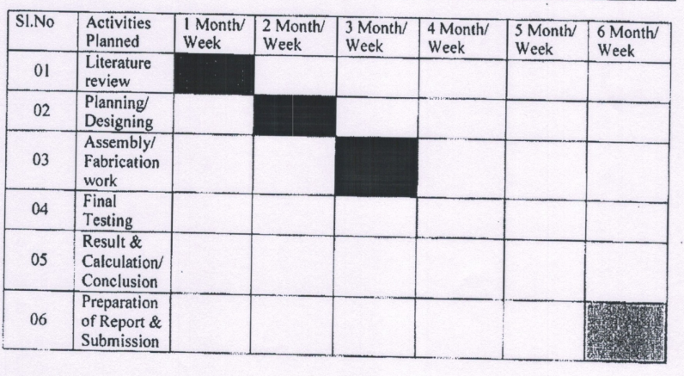

**DECLARATION** **BY THE STUDENTS**

We, the project team hereby declare that the details enclosed in the project proposal (Title of the Project: **Pressure Ulcer Prediction and Prevention**, Branch: **Computer Science and Engineering**, College: **BMS Institute of Technology and Management**) are true and correct to the best of our knowledge. We undertake to inform VTU of any changes therein in the project title, students names will be intimated immediately through the project guide. In case any of the above information is found to be false or untrue or misleading, we are aware that we may be held liable for it.

We are aware that the project team must exhibit/demonstrate the project for evaluation in the VTU Regional centre and exhibition at VTU, Belgavi. If the student team fails to attend the evaluation in the VTU Regional centre and for Exhibition VTU Belgavi, the sponsored project amount will be returned to back to VTU immediately.

We also hereby enclose the endorsement form to VTU, Belgavi.

**Name of the students with USN No. Signature with date**

1. A Nitya Dyuthi 1BY18CS001
2. Khushwinder Singh 1BY18CS074
3. Likith S 1BY18CS081

1. Prakhyat 1BY18CS108

**ENDORSEMENT**

**(From College, endorsement to be taken in the institution / Department Letterhead)**

This is to certify that

**1) Ms. A Nitya Dyuthi**

**2) Mr. Khushwinder Singh**

**3) Mr. Likith S**

**4) Mr. Prakhyat**

Are bonafide student(s) of the Department of **Computer Science and Engineering**, of our institution. If the project proposal submitted by these students under VTU Sponsored Student Project Proposal is selected by VTU, we will provide the requisite laboratory / Computer/infrastructure support in our college / Institution. Further, we also take necessary steps to see that the project team will exhibit/demonstrate their project in the regional centre and Exhibition at VTU, Belgavi. If the student team fails to attend the evaluation in the regional centre and Exhibition at VTU, Belgavi, the supported project amount will be returned back to VTU immediately.

| **(Name & Signature of  Project Guide with Seal)** | **(Signature of HOD with Seal)** | **(Signature of the Principal with Seal)** |
| --- | --- | --- |
| **Name: Mrs. Durga Bhavani A** | **Name: Dr. Thippeswamy G** | **Name: Dr. Mohan Babu G N** |